Title of Final Project



Project ID: F19-00

Session: BSCS Fall 2016 to 2019

Project Advisor: Name of Project Adviser

Submitted By

Name of Student | ID of Student
Name of Student | ID of Student
Name of Student | ID of Student

Department of Computer Science & IT
The University of Lahore
Lahore, Pakistan

Declaration

We have read the project guidelines and we understand the meaning of academic dishonesty, in particular plagiarism and collusion. We hereby declare that the work we submitted for our final year project, entitled Write your project name here is original work and has not been printed, published or submitted before as final year project, research work, publication or any other documentation.

Group Member 1 Name:
SAP No:

Signature: …………………………

Group Member 2 Name:
SAP No:

Signature: …………………………

Group Member 3 Name:
SAP No:

Signature: …………………………

Statement of Submission

This is to certify that Name of Student Roll No. Roll no of Student, Name of Student Roll No. Roll no of Student and Name of Student Roll No. Roll no of Student have successfully submitted the final project named as: Title of the Final Project, at Computer Science & IT Department, The University of Lahore, Lahore Pakistan, to fulfill the partial requirement of the degree of BS in Computer Science.

Supervisor Name: ………………………

Signature: …………………………
Date: ………………………

Dedication

This project is dedicated to my father, who taught me that the best kind of knowledge to have is that which is learned for its own sake. It is also dedicated to my mother, who taught me that even the largest task can be accomplished if it is done one step at a time.

Acknowledgement

We truly acknowledge the cooperation and help make by Name of Acknowledger, Designation of Address of Organization. He has been a constant source of guidance throughout the course of this project. We would also like to thank Acknowledger from Designation, Address of Organization for his help and guidance throughout this project. We are also thankful to our friends and families whose silent support led us to complete our project.

Date:
Jan 1, 2020

Abstract

An abstract is a brief summary of your project. Please focus on the following points to write abstract of you project.

Introduction. This is where you describe the purpose for doing your project or invention.
Problem Statement. Identify the problem you solved or the hypothesis you investigated.
Procedures. ...
Results. ...
Conclusions.

Write one or two paragraphs, do not use bullets.

Area of the Project

Please write the project area here e.g. Machine Leaning, Image Processing, Android Application, Game Application, Web Application, Natural Language Processing, Cloud Computing, Robotics, Artificial Intelligence etc. You can use multiple areas.

Technologies used

Please write all the technologies used in your project e.g. HTML, CSS, JavaScript, .NET, Php, Xampp, MySQL etc.

List of Figures

Figure 1 Usecase Diagram Create Account 5
Figure 2 Architecture Diageam 7
Figure 3 ERD 7
Figure 4 Level 0 DFD 8
Figure 5 Level 1 DFD 8
Figure 6 Class Diagram 9
Figure 7 Activity Diagram Create Account 10
Figure 8 Sequence Diagram Create Account 11
Figure 9 Collaboration Diagram 12
Figure 10 State Transition Diagram 13
Figure 11 Component Diagram 14
Figure 12 Deployment Diagram 15

List of Tables

Table 1 Functional Requirement Create Account 3
Table 2 Usecase Create Account 6
Table 3 Positive Test Case 16
Table 4 Negative Test Case 17
Table 5 Valid Classes and Invalid Classes 18

Table of Content

Declaration i
Statement of Submission ii
Dedication iii
Acknowledgement iv
Abstract v
List of Figures vii
List of Tables viii
Chapter 1: Introduction to the Problem 1
1.1 Introduction 1
1.2 Purpose 1
1.3 Objective 1
1.4 Existing Solution 1
1.5 Proposed Solution 1
Chapter 2: Software Requirement Specification 1
2.1 Introduction 1
2.1.1 Purpose 1
2.1.2 Scope 1
2.1.3 Definitions, acronyms, and abbreviations 1
2.2 Overall description 2
2.2.1 Product perspective 2
2.2.2 Product functions 2
2.2.3 User characteristics 3
2.2.4 Constraints 3
2.2.5 Assumptions and dependencies 4
2.2.6 Apportioning of requirements 4
2.3 Specific requirements 4
2.3.1 Functional Requirement 4
2.3.2 Non-functional Requirements 4
Chapter 3: Use Case Analysis 5
Chapter 4: Design 6
4.1 Architecture Diagram 7
4.2 ERD with data dictionary 7
4.3 Data Flow diagram 8
4.3.1 The level 0 8
4.3.2 The level 1 8
4.4 Class Diagram 9
4.5 Activity Diagram 10
4.6 Sequence Diagram 11
4.7 Collaboration Diagram 12
4.8 State Transition Diagram 13
4.9 Component Diagram 14
4.10 Deployment Diagram 15
Chapter 5: Testing 16
5.1 Test Case Specifications 16
5.2 Black Box Test Cases 17
5.2.1 Equivalence Partitions (EP) 17
5.2.2 Boundary Value Analysis 18
5.2.3 Decision Table Testing 18
5.2.4 State transition Testing 18
5.2.5 Use Case Testing 18
5.3 White Box Test Cases 18
5.3.1 Cyclometric complexity 18
5.4 Performance testing 19
5.5 Stress Testing 19
5.6 System Testing 19
5.7 Regression Testing 19
5.7.1 Selecting Regression Tests 20
5.7.2 Regression Testing Steps 20
Chapter 6: Tools and Techniques 21
Chapter 7: Summary and Conclusion 22
Chapter 8: User Manual 23
Chapter 9: Lessons Learnt and Future Work 24
References 25
Appendix 26

Chapter 1: Introduction to the Problem

Introduction
The Problem introduction gives an explanation about the issue that is being addressed by the project. It also argues in favor of implementing the project in the proposed area in the existing conditions.

Purpose
Define the purpose why you are developing your project what is the need and how this system or project will help in the market or in life of the society

Objective
Define your objectives what you want to achieve after the completion of the project

Existing Solution
Explain the existing solution in the market what are the flows/problems with that existing solutions

Proposed Solution
Explain what you have proposed and how you tackle the problem in the existing products which are related to your project last but not the least why your product is better than the existing solution in the market

Chapter 2: Software Requirement Specification

Introduction

Purpose
This subsection should
- Delineate the purpose of the SRS
- Specify the intended audience for the SRS.

Scope
This subsection should
- Identify the software product(s) to be produced by name
- Explain what the software product(s) will, and, if necessary, will not do
- Describe the application of the software being specified, including relevant benefits, objectives, and goals
- Be consistent with similar statements in higher-level specifications the system requirements specifications, if they exist.

Definitions, acronyms, and abbreviations
This subsection should provide the definitions of all terms, acronyms, and abbreviations required to properly interpret the SRS. This information may be provided by reference to one or more appendixes in the SRS or by reference to other documents.
So here what are definitions, acronyms, and abbreviations
Definitions: a statement of the exact meaning of some words which are used in the document.
Acronyms: name formed as an abbreviation from the initial components in a phrase or a word like NATO - The North Atlantic Treaty Organization. Abbreviations: a shortened form of a word or phrase like UOL is the abbreviation of The University of Lahore

Overall description

Product perspective
This subsection of the SRS should put the product into perspective with other related products. If the product is independent and totally self-contained, it should be so stated here.
A block diagram showing the major components of the system, interconnections, and external inter-faces can be helpful.
This subsection is sub-divided into the following

- System interfaces (functionality of the software to the system requirement)
- User interfaces (define the layout of the user end including the screenshots)
- Hardware interfaces (define the software dependencies if any)
- Software interfaces (define the hardware dependencies if any)
- Communications interfaces (This should specify the various interfaces to communications such as local network protocols etc.)
- Memory (This should specify any applicable characteristics and limits on primary and secondary memory.)
- Operations (specify the normal and special operations like backup and recovery etc.)
- Site adaptation requirements. (Define the requirements for any data or initialization sequences that are specific to a given site, mission, or operational mode)

Product functions
Product functions include the functional requirement of your project

Now what is the functional requirements suppose you have a module of Account
Registration in your project then the functional requirement for this module are Create Account, View Account, Delete Account, Update Account, Login Account, Logout Account etc. and many more according to the situation you are in.

The following things include in each of the functional requirement of your project
- ID
- Name
- Description
- Input
- Output
- Basic Work Flow
- Requirements (optional)

For example, yours create account functional requirement look like this and you have to follow this template for writing your functional requirements

ID: | FR_01
Name: | Create Account
Description | Input | Output | Requirements | Basic Work Flow
Enter details to create account | Name, Email, Password etc. | Account created | Internet Connectivity required | Enter correct information and click submit button  System save the record in database

Table 1 Functional Requirement Create Account

User characteristics
This subsection of the SRS should describe those general characteristics of the intended users of the product including educational level, experience, and technical expertise.

Constraints
This subsection of the SRS should provide a general description of any other items that will limit the developer’s options. These include
- Regulatory policies
- Hardware limitations
- Interfaces to other applications
- Parallel operation
- Audit functions
- Control functions
- Higher-order language requirements;
- Signal handshake protocols
- Reliability requirements
- Criticality of the application
- Safety and security considerations

Assumptions and dependencies
This subsection of the SRS should list each of the factors that affect the requirements stated in the SRS. These factors are not design constraints on the software but are, rather, any changes to them that can affect the requirements in the SRS.

Apportioning of requirements
This subsection of the SRS should identify requirements that may be delayed until future versions of the system.

Specific requirements
This section will describe the functional and non-functional requirements of System at a sufficient level of detail for the designers to design a system satisfying the User requirements and testes to verify that the system satisfies the requirements.

Functional Requirement
In this section only describe the function/modules of your project.

Non-functional Requirements
This sub-section includes the following
- Usability
- Reliability
- Performance
- Design Constraints
- Portability
- Maintainability
- License Agreement

Chapter 3: Use Case Analysis

This chapter includes all the use case diagrams of the functional requirements of your project along with the aggregated usecase diagram
The Usecase diagrams can be made by using Visual Paradigm
- Select Diagram > New from the application toolbar.
- In the New Diagram window, select Use Case Diagram.
- Click Next.
- Enter the diagram name and description.
- Click OK.
The following things include in each of the functional requirement of your project
- Usecase ID
- Usecase Name
- Description
- Primary Actor
- Secondary Actor
- Pre-Condition
- Post-Condition
- Basic Flow
- Alternate Flow
For example, yours create account use case look like this and you have to follow this template for writing your use cases
Usecase diagram for create account
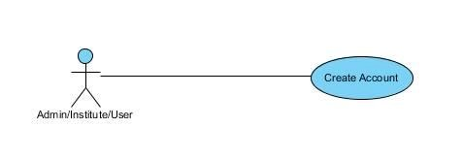
Figure 1 Usecase Diagram Create Account

Usecase diagram detail

Use Case ID | UC_01 (all ID should be in this sequence)
Use Case Name | Create Account (Name of usecase here is create account)
Description | Detail of this usecase
Primary Actor | Actors associate with the usecase
Secondary Actor
Pre-Condition | What is required to do this function
Post-Condition | What is the output of this function
Basic Flow | Actor Action | System Action
 | Flow of information | What would system do according to the information
Alternate Flow | Another way to work with this function

Table 2 Usecase Create Account

Chapter 4: Design

In this section, we provide the design analysis of our modules including the following designs
- Architecture Diagram
- ERD with data dictionary
- Data Flow diagram
- Class Diagram
- Activity Diagram
- Sequence Diagram
- Collaboration Diagram
- State Transition Diagram
- Component Diagram
- Deployment Diagram

Architecture Diagram
Define the graphical representation of the concepts, their principles, elements and components that are part of your project.

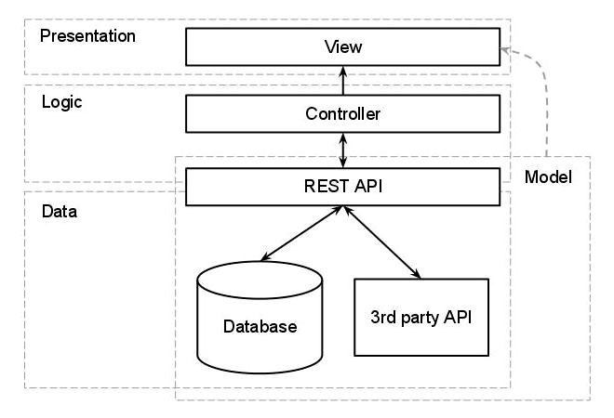
Figure 2 Architecture Diageam

ERD with data dictionary
Entity Relationship Diagram with complete relations with dependencies of your project

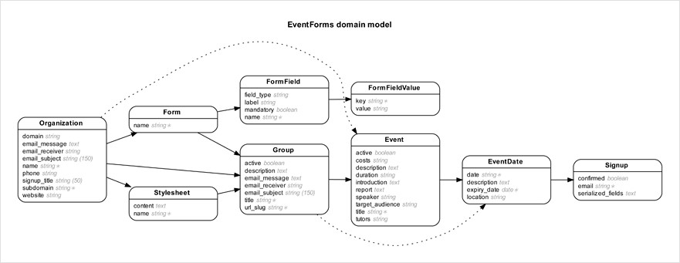
Figure 3 ERD

Data Flow diagram
Data flow diagram includes two levels

The level 0
The flow of information inside the system is defined in this level

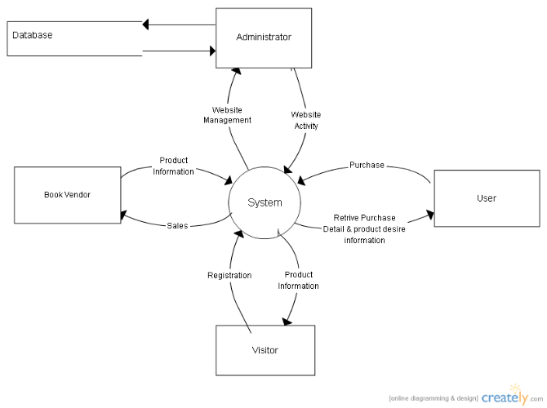
Figure 4 Level 0 DFD

The level 1
The flow of information outside the system is defined in this level

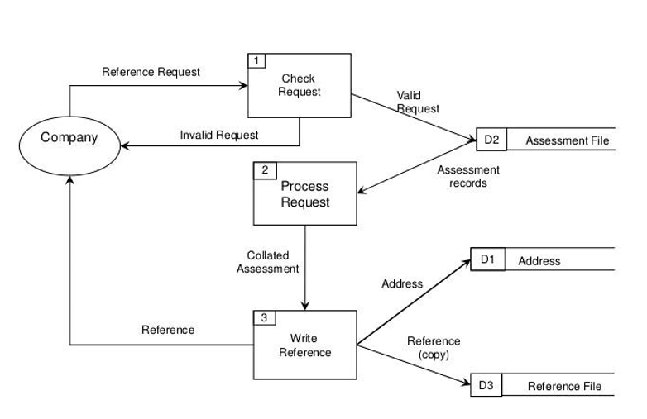
Figure 5 Level 1 DFD

Class Diagram
Describe the structure of a project by showing the systems classes, their attributes, operations (or methods), and the relationships among objects.

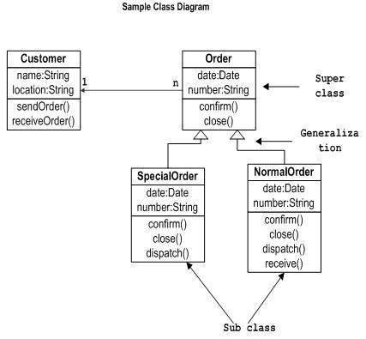
Figure 6 Class Diagram

Activity Diagram
This diagram includes all the activity diagrams of the functional requirements of your project along with the aggregated activity diagram
The Activity diagrams can be made by using Visual Paradigm
- Select Diagram > New from the application toolbar.
- In the New Diagram window, select Activity Diagram.
- Click Next.
- Enter the diagram name and description.
- Click OK.
6.
For example, yours create account activity look like this and you have to follow this template for writing your activity diagrams
Activity diagram for create account
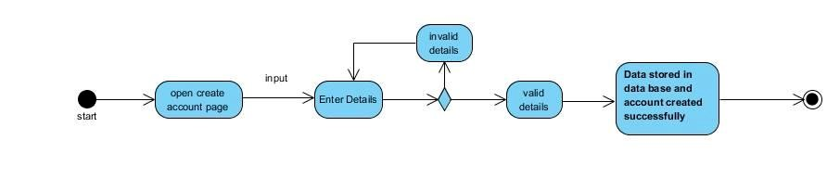
Figure 7 Activity Diagram Create Account

Sequence Diagram
This diagram includes all the Sequence diagrams of the functional requirements of your project along with the aggregated Sequence diagram
The Sequence diagrams can be made by using Visual Paradigm
- Select Diagram > New from the application toolbar.
- In the New Diagram window, select Sequence Diagram.
- Click Next.
- Enter the diagram name and description.
- Click OK.

For example, yours create account Sequence look like this and you have to follow this template for writing your Sequence diagrams
Sequence diagram for create account
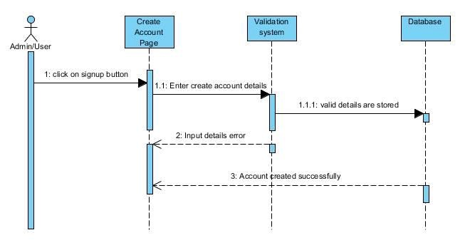
Figure 8 Sequence Diagram Create Account

Collaboration Diagram
It shows the object organization as shown below. Here in collaboration diagram the method call sequence is indicated by some numbering technique as shown below. The number indicates how the methods are called one after another. We have taken the same order management system to describe the collaboration diagram.
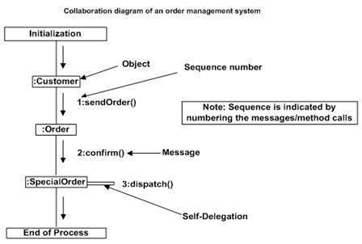

Figure 9 Collaboration Diagram

State Transition Diagram
State Transition diagram is used to describe the states of different objects in its life cycle. So, the emphasis is given on the state changes upon some internal or external events. These states of objects are important to analyze and implement them accurately
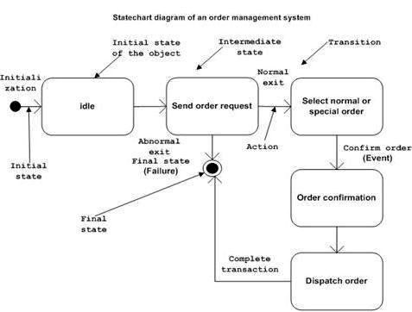
Figure 10 State Transition Diagram

Component Diagram
Component diagrams are used to describe the physical artifacts of a system. This artifact includes files, executables, libraries etc.
So, the purpose of this diagram is different, Component diagrams are used during the implementation phase of an application. But it is prepared well in advance to visualize the implementation details.

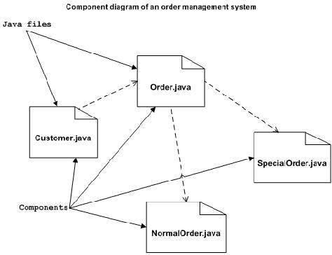

Figure 11 Component Diagram

Deployment Diagram
Deployment diagram represents the deployment view of a system. It is related to the component diagram. Because the components are deployed using the deployment diagrams. A deployment diagram consists of nodes. Nodes are nothing but physical hardware’s used to deploy the application.
Deployment diagrams are useful for system engineers. An efficient deployment diagram is very important because it controls the following parameters
- Performance
- Scalability
- Maintainability
- Portability

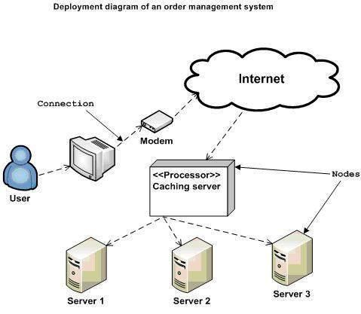
Figure 12 Deployment Diagram

Chapter 5: Testing

Test Case Specifications
This Testing phase includes all the Test Cases of the functional requirements of your project
For example, your login account test case looks like this and you have to follow this template for writing your project test cases
Test Case for login account
 | Positive Test Case
ID | TC_LOGIN_SUCCESS
Priority | High
Description | To verify user authentication to system.
Reference | Functional Requirement reference
Users | Administrator.
Pre-requisites | A | System is online.
 | B | User must have active login credentials provided by system administrator.
 | C | User has internet access.
Steps | A | Open the web link to system.
 | B | Enter login id
 | C | Enter Password.
 | D | Press Login.
Input | Login id and password
Expected result | Successfully enters the system and main home page opens.
Status | Tested, passed.

Table 3 Positive Test Case

 | Negative Test Case
ID | TC_LOGIN_FAILURE
Priority | High
Description | To verify user authentication to system.
Reference | Functional Requirement reference
Users | Administrator.
Pre-requisites | A | System is online.
 | B | User must have active login credentials provided by system administrator.
 | C | User has internet access.
Steps | A | Open the web link to system.
 | B | Enter login id.
 | C | Enter Password.
 | D | Press Login.
Input | Incorrect Login id or password or deactivated credentials.
Expected result | Does not allows access to system features and notifies the error.
Status | Tested, passed.

Table 4 Negative Test Case

Black Box Test Cases
Black box testing also known as Behavioral Testing, is a software testing method in which the internal structure/ design/ implementation of the item being tested is not known to the tester. These tests can be functional or non-functional, though usually functional.
This method is named so because the software program, in the eyes of the tester, is like a black box; inside which one cannot see. This method attempts to find errors in the following categories:
- Incorrect or missing functions
- Interface errors
- Errors in data structures or external database access
- Behavior or performance errors
- Initialization and termination errors

Equivalence Partitions (EP)
Equivalence class partitioning (EP) is a very widely used method to decrease the number of possible test cases that are required to test a system.
Let see the example of Equivalence Partitions for login Authentication

Variables | Valid Classes |  | Invalid Classes
Username | 1. 2.  3. | Only username “admin”.  Case in-sensitive.  Compulsory field. | - Alphabets, digits and symbols other than “admin”.  - Empty Field.
Password | 1.  2. | Length should be greater than 5 characters.  May contain symbols, alphabets [a-z A-Z] and digits [0-9]. | - Length less than 5 characters.  - Empty field.

Table 5 Valid Classes and Invalid Classes

Boundary Value Analysis
A boundary value is an input or output value on the border of an equivalence partition, includes minimum and maximum values at inside and outside boundaries. Normally Boundary value analysis is part of stress and negative testing.

Decision Table Testing
Decision Table is a testing method, which aims to ensure that each one of the possible branch from each decision point is executed at least once and thereby ensuring that all reachable code is executed.

State transition Testing
State Transition testing, a black box testing technique, in which outputs are triggered by changes to the input conditions or changes to 'state' of the system. In other words, tests are designed to execute valid and invalid state transitions.

Use Case Testing
Use Case Testing is a functional black box testing technique that helps testers to identify test scenarios that exercise the whole system on each transaction basis from start to finish.

White Box Test Cases
White box testing is a testing technique, that examines the program structure and derives test data from the program logic/code. The other names of glass box testing are clear box testing, open box testing, logic driven testing or path driven testing or structural testing.

Cyclometric complexity
Cyclometric complexity is a source code complexity measurement that is being correlated to a number of coding errors. It is calculated by developing a Control Flow Graph of the code that measures the number of linearly-independent paths through a program module.
Lower the Program's cyclometric complexity, lower the risk to modify and easier to understand.

Performance testing
Performance testing, a non-functional testing technique performed to determine the system parameters in terms of responsiveness and stability under various workload. Performance testing measures the quality attributes of the system, such as scalability, reliability and resource usage.

Stress Testing
Stress testing a Non-Functional testing technique that is performed as part of performance testing. During stress testing, the system is monitored after subjecting the system to overload to ensure that the system can sustain the stress.
The recovery of the system from such phase (after stress) is very critical as it is highly likely to happen in production environment.

System Testing
System Testing (ST) is a black box testing technique performed to evaluate the complete system the system's compliance against specified requirements. In System testing, the functionalities of the system are tested from an end-to-end perspective.
System Testing is usually carried out by a team that is independent of the development team in order to measure the quality of the system unbiased. It includes both functional and NonFunctional testing.

Regression Testing
Regression testing a black box testing technique that consists of re-executing those tests that are impacted by the code changes. These tests should be executed as often as possible throughout the software development life cycle. Types of Regression Tests:

Final Regression Tests
A "final regression testing" is performed to validate the build that hasn't changed for a period of time. This build is deployed or shipped to customers.

Regression Tests
A normal regression testing is performed to verify if the build has NOT broken any other parts of the application by the recent code changes for defect fixing or for enhancement.

Selecting Regression Tests
- Requires knowledge about the system and how it affects by the existing functionalities.
- Tests are selected based on the area of frequent defects.
- Tests are selected to include the area, which has undergone code changes many a times.
- Tests are selected based on the criticality of the features.

Regression Testing Steps
Regression tests are the ideal cases of automation which results in better Return on Investment (ROI).
- Select the Tests for Regression.
- Choose the apt tool and automate the Regression Tests
- Verify applications with Checkpoints
- Manage Regression Tests/update when required
- Schedule the tests
- Integrate with the builds
- Analyze the results

Chapter 6: Tools and Techniques

This chapter includes the following
- Languages you are using in the development
- Applications and tools
- Libraries and Extensions if any

Chapter 7: Summary and Conclusion

This chapter include the summary and the conclusion

Chapter 8: User Manual

User manual is an important part of an application documentation. It is a guide for users on operations within the application. Follow section of this document will provide detailed guide on how to use features of application.
let take the login function as an example
This is the login authentication screen from where the user can log in to the system. User must have
- Active username and password.
- Web login address.
Steps:
- Open login webpage
- Enter login details.
- Click Login.
- Done.

Chapter 9: Lessons Learnt and Future Work

In this chapter you will explain the lesson learned from the project and future work that is not the part of your project but you want to do in future.

References

The references shall be quoted in the following format as provided by IEEE:

Reference examples
There are standard reference formats for most types of document. Below are examples of the most common types of document you might want to reference. Each of the following gives a suggested standard format for the reference followed by examples for the different document types.

Book
[Ref number] Author’s initials. Author’s Surname, Book Title, edition (if not first). Place of publication: Publisher, Year.

- I.A. Glover and P.M. Grant, Digital Communications, 3rd ed. Harlow: Prentice Hall, 2009.

Book chapter
[Ref number] Author’s initials. Author’s Surname, “Title of chapter in book,” in Book Title, edition (if not first), Editor’s initials. Editor’s Surname, Ed. Place of publication: Publisher, Year, page numbers.

- C. W. Li and G. J. Wang, "MEMS manufacturing techniques for tissue scaffolding devices," in Mems for Biomedical Applications, S. Bhansali and A. Vasudev, Eds. Cambridge: Woodhead, 2012, pp. 192-217.

Electronic Book
[Ref number] Author’s initials. Author’s Surname. (Year, Month Day). Book Title (edition) [Type of medium]. Available: URL

- W. Zeng, H. Yu, C. Lin. (2013, Dec 19). Multimedia Security Technologies for Digital Rights Management [Online]. Available: http://goo.gl/xQ6doi

Note: If the e-book is a direct equivalent of a print book e.g. in PDF format, you can reference it as a normal print book.

Journal article
[Ref number] Author’s initials. Author’s Surname, “Title of article,” Title of journal abbreviated in Italics, vol. number, issue number, page numbers, Abbreviated Month Year.

- F. Yan, Y. Gu, Y. Wang, C. M. Wang, X. Y. Hu, H. X. Peng, et al., "Study on the interaction mechanism between laser and rock during perforation," Optics and Laser Technology, vol. 54, pp. 303-308, Dec 2013.

Note: the above example article is from a journal which does not use issue numbers, so they are not included in the reference.

E-Journal article
PDF versions of journal articles are direct copies of the print edition, so you can cite them as print journals.
[Ref number] Author’s initials. Author’s Surname. (Year, Month). “Title of article.” Journal Title [type of medium]. volume number, issue number, page numbers if given. Available: URL

- M. Semilof. (1996, July). “Driving commerce to the web-corporate intranets and the internet: lines blur”. Com

Conference papers
[Ref number] Author’s initials. Author’s Surname, “Title of paper,” in Name of Conference, Location, Year, pp. xxx.

- S. Adachi, T. Horio, T. Suzuki. "Intense vacuum-ultraviolet single-order harmonic pulse by a deep-ultraviolet driving laser," in Conf. Lasers and Electro-Optics, San Jose, CA, 2012, pp.2118-2120.

Theses/Dissertations
[Ref number] Author’s initials. Author’s Surname, “Title of thesis,” Designation type, Abbrev. Dept., Abbrev. Univ., City of Univ., State, Year.

- J. O. Williams, “Narrow-band analyser,” Ph.D. dissertation, Dept. Elect. Eng., Harvard Univ., Cambridge, MA, 1993

Online Documents
If you are using documents such as a report, conference paper, standard, patent or thesis online and it also exists as an identical print equivalent i.e. with the same format and pagination, it can be usually be referenced as the print version.

If it is e-only, you can make the standard reference template an electronic version by adding the material type in square brackets e.g. [Online] after the document title. If there is no specific document title you can place this after the document number (e.g. patent number).

At the end of the reference add: Available: URL. See below for an example of an online patent:

- M.R. Brooks, “Musical toothbrush with adjustable neck and mirror,” U.S Patent 326189 [Online], May 19 1992. Available: http://goo.gl/VU1WEk

Websites
Note: Include as much of the key information as you can find for a given website. If a web page has no personal author, you can use a corporate author. Failing that, you can use either Anon. (for anonymous) or it is permissible to use the title of the site.

[Ref number] Author’s initials. Authors Surname. (Year, Month. Day). Title of web page [Online]. Available: URL

- BBC News. (2013, Nov. 11). Microwave signals turned into electrical power [Online]. Available: http://www.bbc.co.uk/news/technology-24897584

- M. Holland. (2002). Guide to citing internet sources [Online]. Available: http://www.bournemouth.ac.uk/library/using/guide_to_citing_inter

How to cite the references:
In order to cite the references in the text the reference numbers are to be placed in square brackets and interlaced in the text. For example, A comprehensive detail of how to prevent accidents and losses caused by technology can be found in the literature [1].

A project report/document/thesis cannot be accepted without proper references.

Appendix
- A section at the end of a document that includes information that is too detailed for the text of the document itself and would "burden the reader" or be "distracting," or "inappropriate" (APA, 2010, p. 38-9).
- The content in the appendices should be "easily presented in print format" (APA, 2010, p. 39).
  - Examples:
    - lists of length (short lists belong in the document itself)
    - detailed descriptions (essential details should be in the document itself)
    - a list of articles that support data but are not referred to in the document itself
    - demographic details for subpopulations studied by the document



